Below are some projects I have worked on just for the fun of it!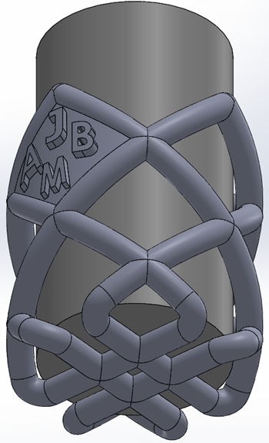

Cup Holder for Crutches

My older brother and I designed this cup holder for holding cans. He attached it to one of his crutches with zip ties and used it to hold cans of fizzy water.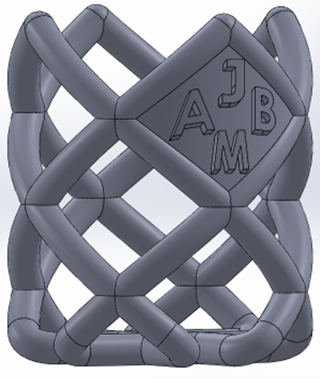

Doggy Stairs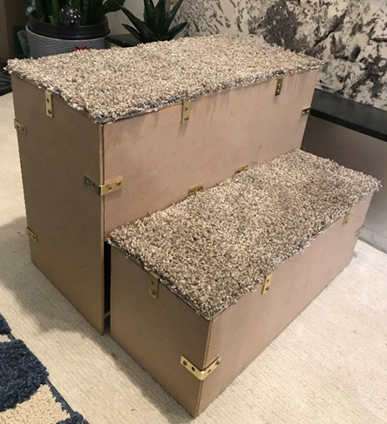

My younger brother and I designed and built these folding stairs together. We made them to help our dog climb onto furniture that is a little high for him.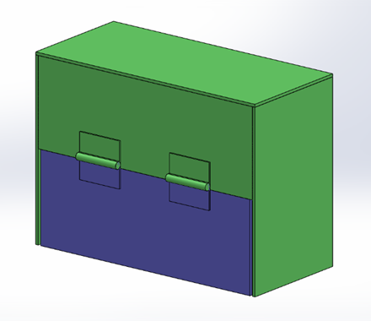

Phone Holder Bike Attachment

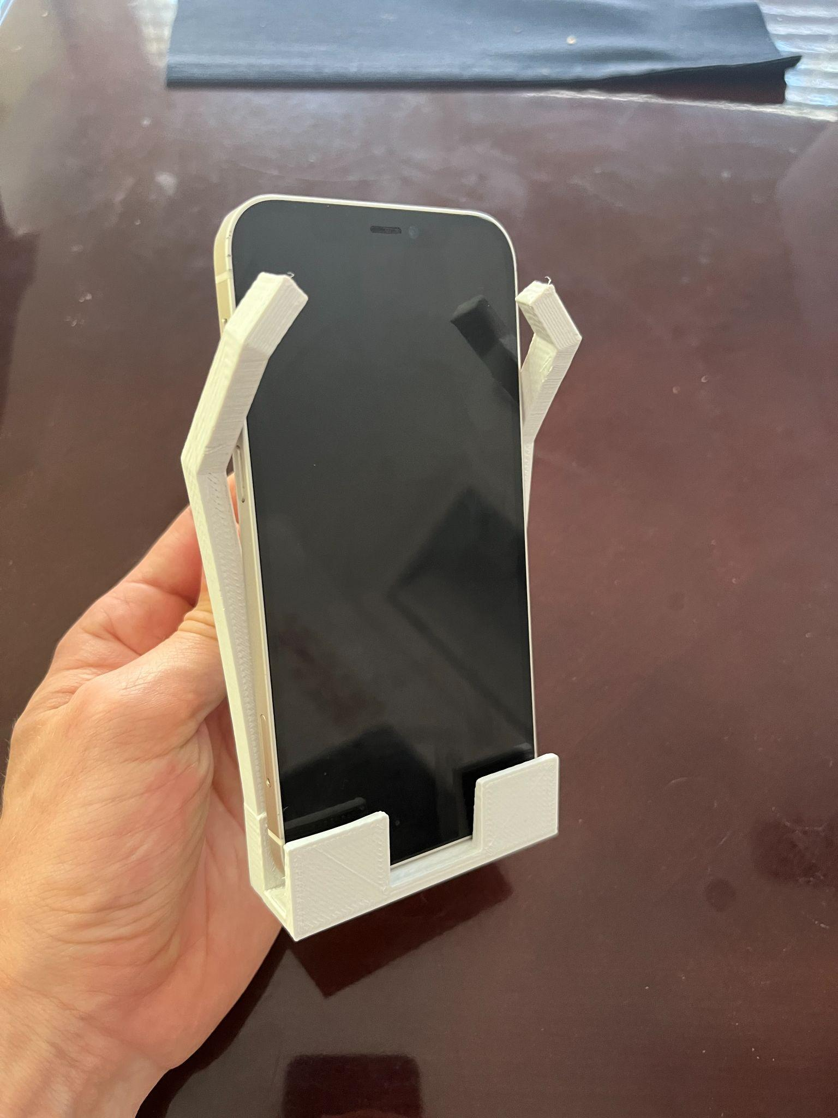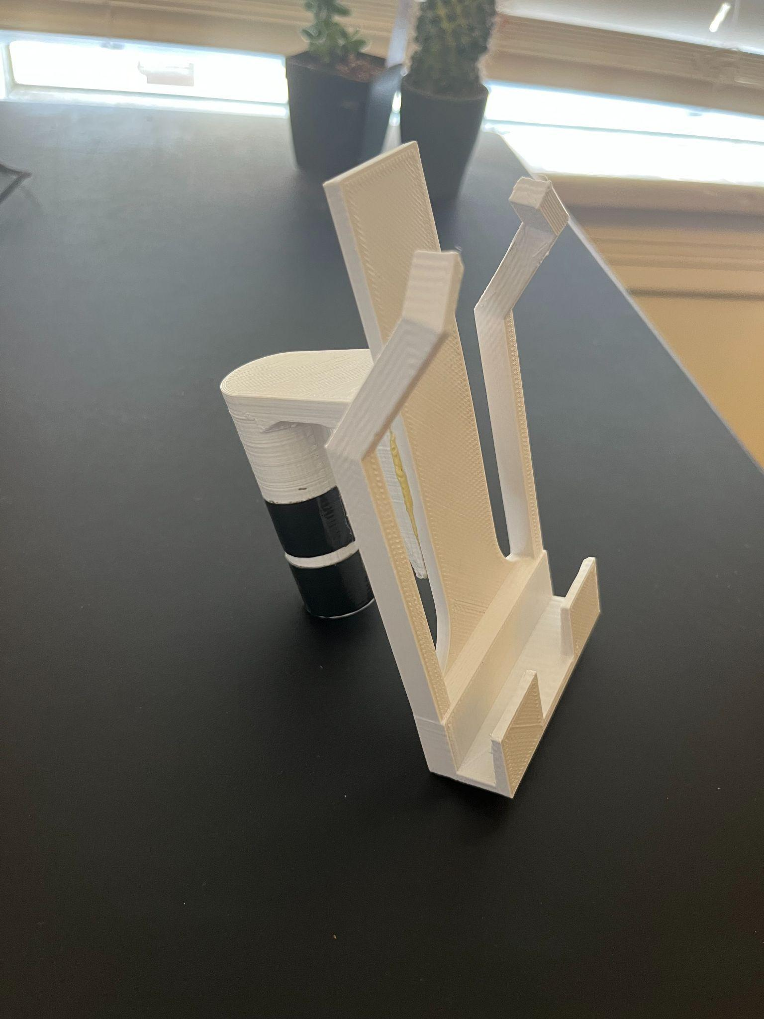

I have a mount on my bike that holds a flashlight. I wanted to be able to safely display my phone on my handlebars for navigation/music during bike rides, so I designed a phone holder that would fit into the flashlight mount.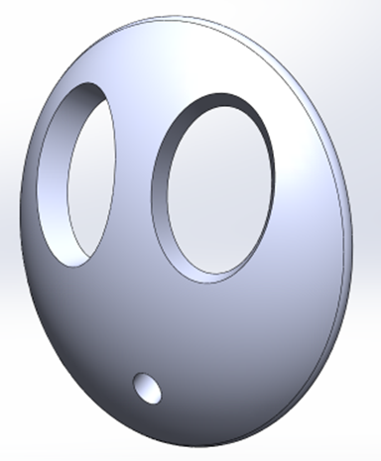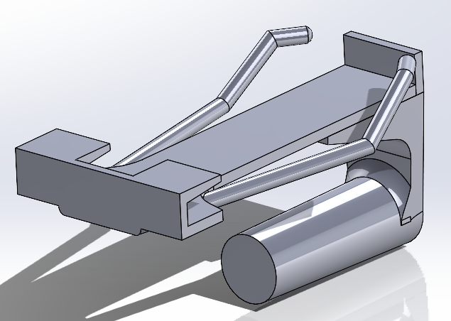

Shy Guy Mask

My younger brother and I designed this mask together, based on the Super Mario character Shy Guy. I 3D printed it for him as part of a shy guy costume he is making.

Succulent Pot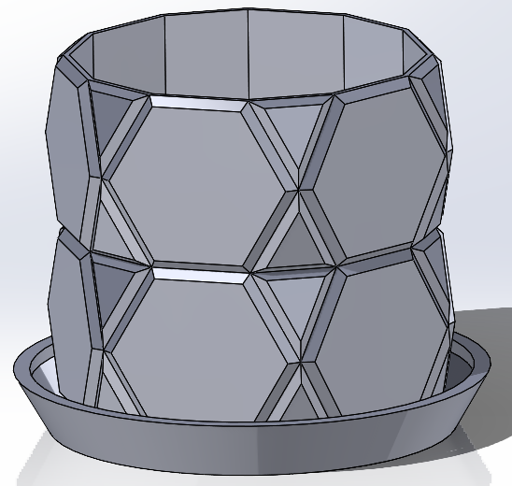

A family friend really liked succulents so I modeled and 3D printed a pot with built-in drainage and tray for her.

Scuba Helmet Decoration

